

MONDAY - THURSDAY DRESS:

SLACKS or CAPRIS: Any solid color –NOT form fitting or tight

SKIRTS or JUMPERS Any solid color
& DRESSES: MUST come to the knee
It is not to be tight or form fitting

NO sleeveless dresses
(For elementary - privacy shorts need to be worn under skirt, dress or jumper)

SHIRTS: Any solid color Pullover Polo shirts, long or short sleeve w/no large logo’s – no larger than quarter size
Any solid color Oxford Shirt - long or short sleeve
No sleeveless shirts

SHORTS: Solid Color Docker Style
No shorter than 3 inches from the knee

SWEATERS & JACKETS: Any solid color with no writing

SWEATSHIRTS: Must be a Gateway sweatshirt or solid color

SHOES: Tennis shoes or any other shoe or sandal (No high heels for elementary) No rubber sole flip-flops of any kind can be worn

HAIR: Hair length for boys should not extend below the bottom of the collar
Hair should stay out of the eyes
Hair should be natural colors
Hair should be neat and clean
No Facial Hair

FRIDAY DRESS:
PANTS: Blue jeans, must not be torn or worn out. NOT form fitting or tight
Same as Mon-Thursday
BOYS: May wear blue jean shorts
GIRLS: May wear blue jean capris
SHIRT: Gateway spirit shirts
Gateway sweatshirts
Same as Mon-Thursday

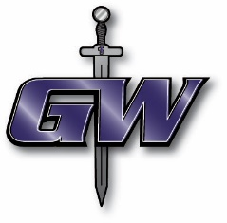
IF YOU ARE NOT SURE - ASK BEFORE YOU BUY. ALL CLOTHING MUST BE MODEST.

